1. What is Jenkins used for : Jenkins is used to build and test your product continuously, so developers can continuously integrate changes into the build. Jenkins is the most popular open source CI/CD tool on the market today and is used in support of DevOps, alongside other cloud native tools.
2. 2) What is Jenkins agent? What is Jenkins executor (Build Executor) >> **one of the basic building blocks which allow a build to run on a node/agent** (e.g. build server). Think of an executor as a single "process ID", or as the basic unit of resource that Jenkins executes on your machine to run a build
3. Explain Jenkins master-slave architecture ?  
   

***Jenkins Master***

1. *Your main Jenkins server is the Master. The Master’s job is to handle:*
2. Scheduling build jobs.
3. *Dispatching builds to the slaves for the actual execution.*
4. Monitor the slaves (possibly taking them online and offline as required).
5. Recording and presenting the build results.
6. A Master instance of Jenkins can also execute build jobs directly.

***Jenkins Slave***

*A Slave is a Java executable that runs on a remote machine. Following are the characteristics of Jenkins Slaves:*

1. It hears requests from the Jenkins Master instance.
2. *Slaves can run on a variety of operating systems.*
3. *The job of a Slave is to do as they are told to, which involves executing build jobs dispatched by the Master.*
4. *You can configure a project to always run on a particular Slave machine or a particular type of Slave machine, or simply let Jenkins pick the next available Slave*
5. Install jenkins with docker image .  
     
     
   

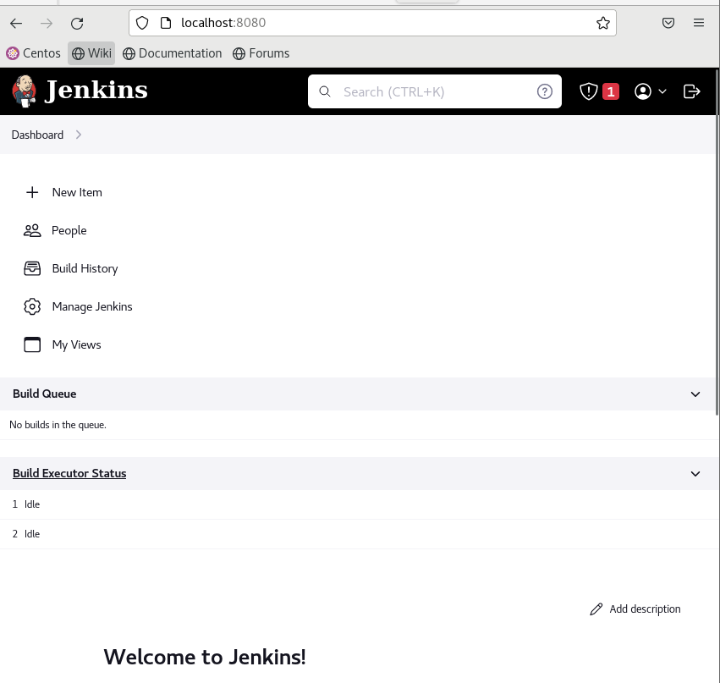

1. Create free style project and link it to private git repo containing any dockerfile then build an image from this dockerfile and push it to private docker repo

